Given a list of strings - List[String] (“alpha”, “gamma”, “omega”, “zeta”, “beta”)

Val list = List((“alpha”, “gamma”, “omega”, “zeta”, “beta”)

**TASK 1: find count of all strings with length 4**

List.count(s=>s.length==4)

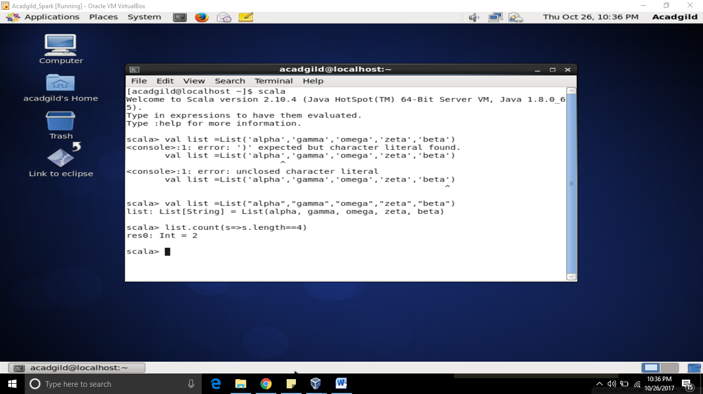

**TASK 2: convert the list of string to a list of integers, where each string is mapped to its**

**Corresponding length**

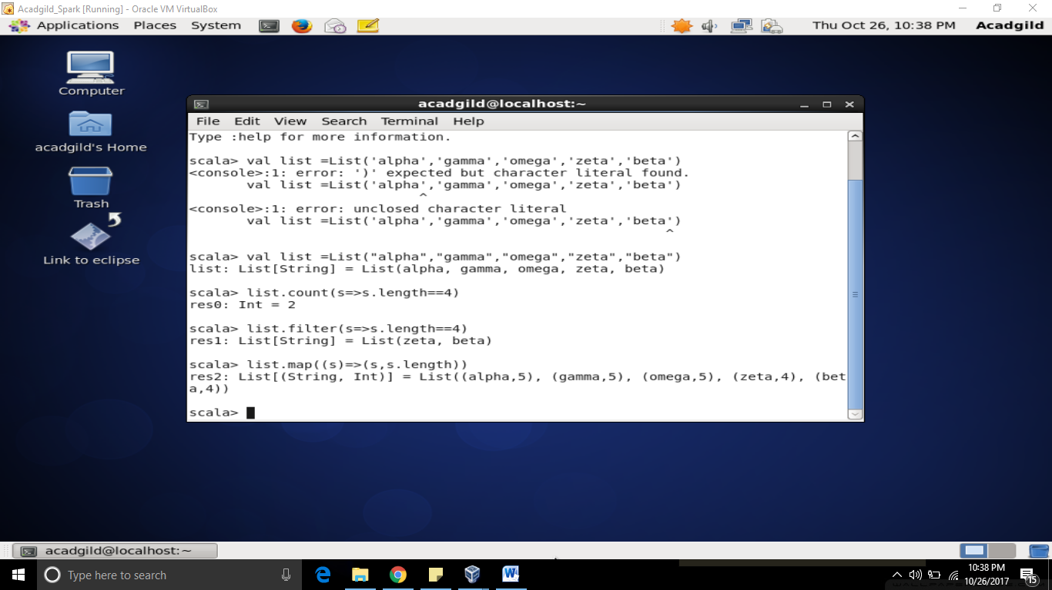

**TASK 3 : find count of all strings which contain alphabet ‘m’**

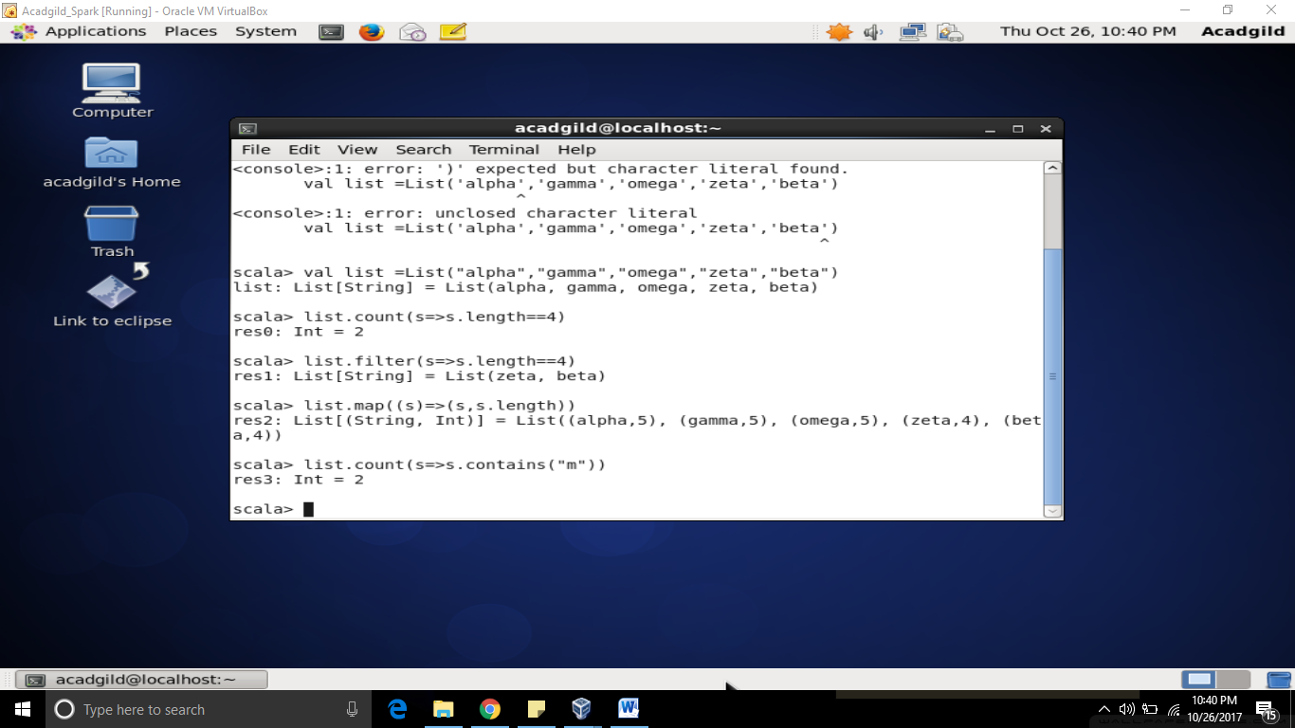

**TASK4: find the count of all strings which start with the alphabet ‘a’**

